**Command Line Arguments**

**LAB # 07**



**Spring 2023**

**CSE-204L Operating Systems Lab**

Submitted by: S**uleman Shah**

Registration No.: **21PWCSE1983**

Class Section: **C**

“On my honor, as student of University of Engineering and Technology, I have neither given nor received unauthorized assistance on this academic work.”

Submitted to:

**Engr. Madiha Sher**

Date:

**19th May 2023**

**Department of Computer Systems Engineering**

**University of Engineering and Technology, Peshawar**

**Objectives:**

* To comprehend the concept of command-line parameters and their usage in C programming.
* To acquire knowledge on accessing and manipulating command-line parameters in a C program.
* To delve into process creation and execution using command-line parameters.

**Task 1:**

Write a C program that finds the sum of all CLA’s.

**Code Screenshot:**

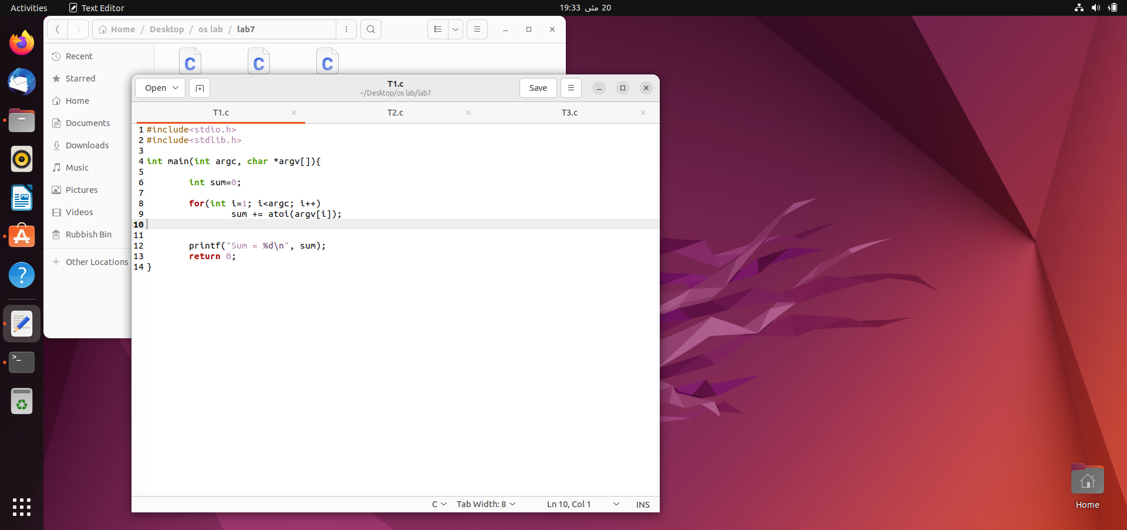

**Output Screenshot:**

**Task 2:**

Write a C program that creates a child process & execute task 1 in child process using execlp() system call. Parent process shall wait for the child process.

**Code Screenshot:**

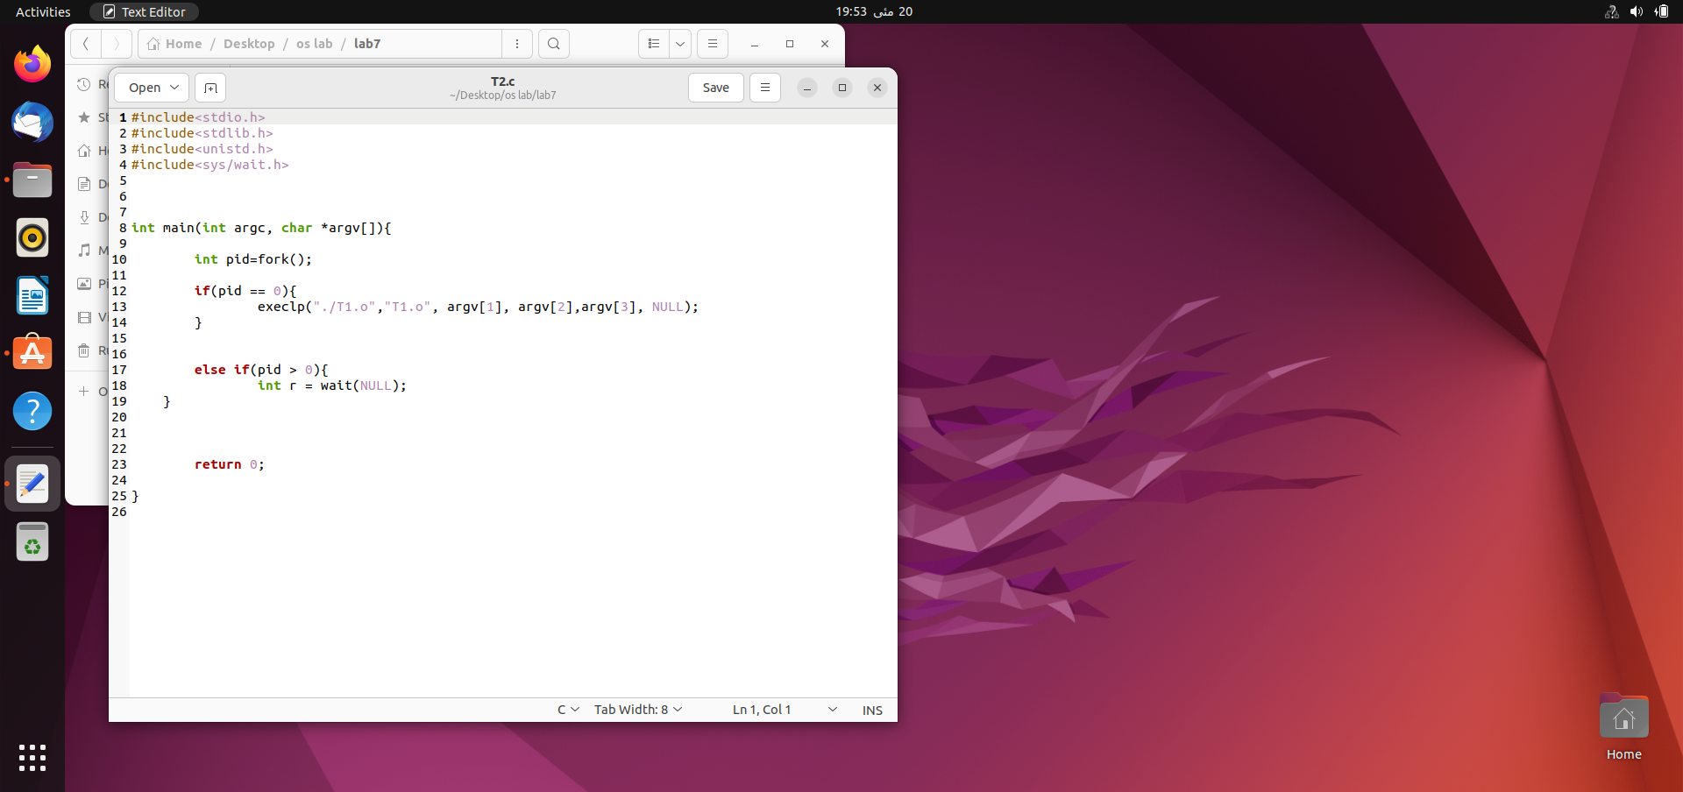

**Output Screenshot:**

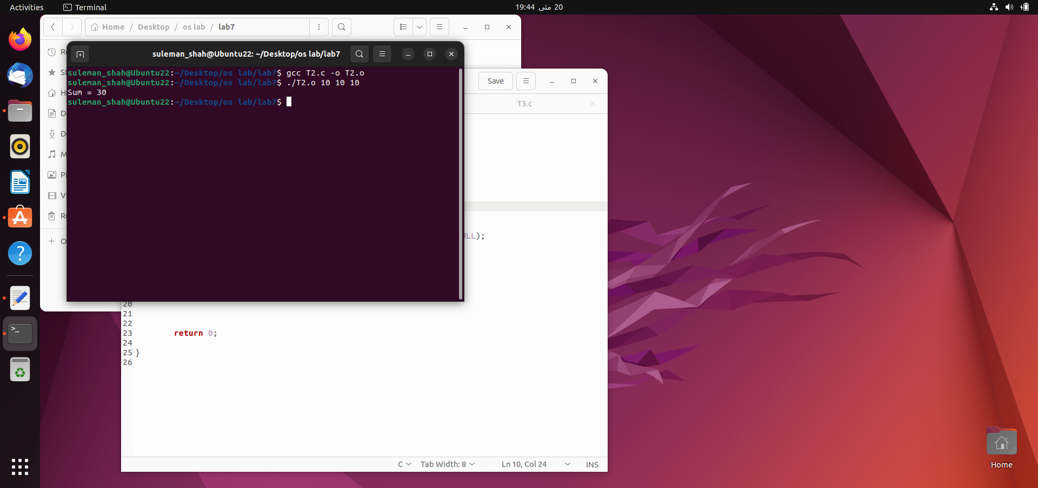

**Task 3:**

Write a C program that takes built-in command on CLA’s and create separate child process for each command & execute these commands in child process. Parent shall wait for the child processes.

**Code Screenshot:**

**Output Screenshot:**

